

Student Learning & Experience Committee

Resilience Review Tool

Document Owner: Student Learning & Academic Registry
Version number: 5.0
Effective date: September 2023 (Academic Year 2023-24)
Date of next review: July 2024
This document is part of the University Quality Framework, which governs the University’s academic provision.

Purpose of the Resilience Review Tool

The purpose of the Resilience Review Tool (RRT) is to provide a temporary 'tool' for Course Teams to work through the extent to which their course could be delivered within the Hybrid Model without the student experience being unduly impacted upon, owing to extreme circumstances beyond the control of Teesside University. This will ensure that the University continues to meet the expectations of the QAA and the OfS. The tool should be used in conjunction with the attached Academic Enhancement Framework (Hybrid Model) Matrix, the wider Academic Enhancement Framework (AEF) and PSRB guidance.

The Academic Enhancement Framework (Hybrid Model) is designed to support staff, partners, and students in understanding the expectations and key principles aligned with the implementation of the hybrid delivery model.

Resource implications relating to this planning should be raised with the HoD and be articulated within the School Business Recovery Plan.

Process

An RRT must be completed for every course/group of courses (as per the CME processes) affected by unforeseen circumstances, detailing implications for different modes and occurrences. In completing the RRT, Course Leaders should have due regard to implications arising from the modules being delivered on multiple courses. Transitional proposals should normally be presented for the delivery of a hybrid model for the full academic year. There will be the opportunity for a review of arrangements should the need arise. Courses operating non-semesterised delivery should also complete an RRT. Completed RRTs will be checked and approved by a virtual School SLESC panel, which will include appropriate Student Learning & Academic Registry representation. This process will be utilised to check the coherence of structure and delivery against the learning, teaching and assessment strategy and ensure any temporary adaptations have not compromised the course learning outcomes or student experience.

Changes to the course and modules will be deemed ‘temporary’, and the hybrid version of a course will not change or update the permanent version of the course specification on the Programme Catalogue or the modules on the UTREG system. Documentation approved under the hybrid model will be stored in a documentation repository on the Student Learning & Academic Registry Programme Catalogue SharePoint site.

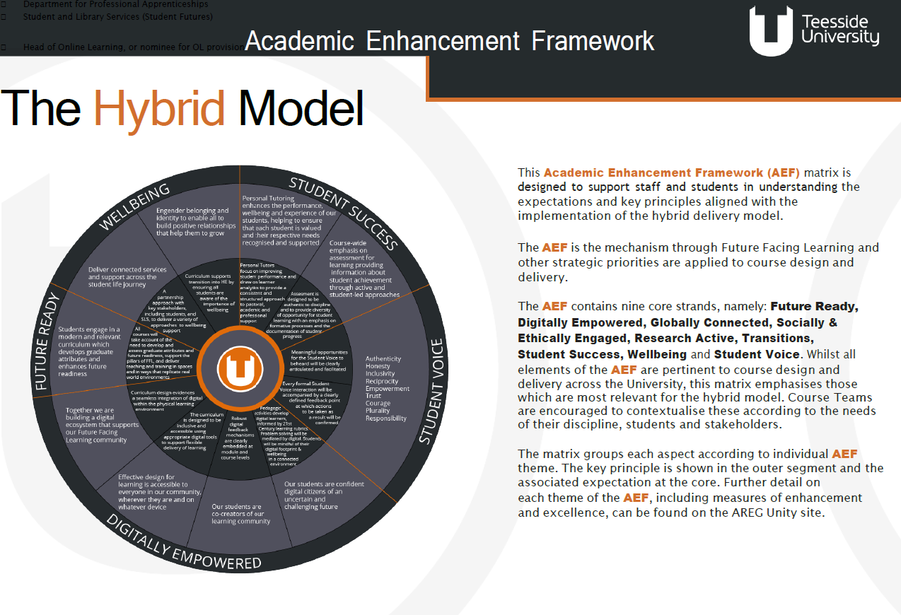
Following approval of the RRT, Course Leaders must ensure that the School Module Assessment Tracker is completed for all
modules affected and ensure assessments align with proposals outlined within the strategy in the RRT. Schools will also be required to make any appropriate changes to Course and Module handbooks.

School
Partner (if applicable)

Course Title

Course Leader

Link Tutor (if applicable)
Academic Year (e.g., 20XX-XX)

Date

PLEASE SUBMIT THE COMPLETED RRT FORM TO THE SLAR (QAV) IN STUDENT LEARNING & ACADEMIC REGISTRY via email to QAV@tees.ac.uk

Key Area of Course Delivery | Course Team Considerations and Reflections | CPD Requirements
Course/Module Learning Outcomes | Please consider the principles and expectations on the attached Matrix around: Future Ready, Student Success and Student Voice. | Please capture specific course wide CPD requirements for achieving the desired impact and outcomes at a course level.
Please provide an overview around the extent to which course/module learning outcomes are appropriate/in need of modification under the Hybrid Delivery Model.

Quality Considerations
Please confirm that all module/course outcomes remain appropriate or detail any temporary adaptations and the rationale for the changes.
Assessment and Feedback | Please consider the principles and expectations on the attached Matrix around: Future Ready and Student Success. | Please capture specific course wide CPD requirements for achieving the desired impact and outcomes at a course level.
Please provide detail around the extent to which course/module assessment and reassessment strategies/progression points remain appropriate/are in need of modification under the Hybrid Delivery Model.

Please also refer to the University’s Assessment and Feedback Policy.

Quality Considerations
Will the proposed temporary changes to delivery/mode require any temporary assessment changes? Consider the implications on the assessment chart, submission dates, and scheduling of Module and Progression/Award Assessment Boards.

These changes to the assessment strategy will need to align with the University module assessment tracker, although the specific detail of changes to module assessment will be collated through the module assessment tracker.

Will any approved variances remain in place/appropriate?

Approaches/Adaptations to Course Structure/Delivery | Please consider ALL the principles and expectations on the attached AEF Matrix around: Digital Empowerment. | Please capture specific course wide CPD requirements for achieving the desired impact and outcomes at a course level.
Please provide detail around the extent to which planned (pedagogic) approaches to course delivery at module level strategies remain appropriate/are in need of modification under the Hybrid Delivery Model.

A hybrid approach will usually combine two core elements: classroom-based activities with the lecturer present (subject to social distancing); and online learning materials with lecturer support (which may be used in different ways). Key considerations for a systematic approach to constructing a hybrid learning design for your module include:

Planning your module
- Decide what students need to learn and how it will be delivered.
- Designing with a coherent flow of learning (with a mixture of classroom-based learning for modules or elements where learning can take place on campus), asynchronous learning, synchronous learning, collaborative active learning and independent study.
- Design with Universal Design for Learning (UDL) principles in mind.
- Consider how online tools can be utilised to promote communities of learning.

https://blogs.tees.ac.uk/lteonline/digital-delivery-learning-and-support/

https://blogs.tees.ac.uk/lteonline/2019/03/21/planning-for-diversity-with-udl/

Approaches to designing a hybrid module and constructing content
Designing deep and active learning through collaboration and construction of knowledge and learning activities:
- What does collaboration look like on your course (opportunities for negotiation, sharing, joint inquiry)?
- Does the course promote high levels of engagement to afford the construction of new knowledge and learning?

A key consideration of designing active online learning is the need for tutor engagement with student learning, supporting students to scaffold their learning and develop a deep and critical understanding of the subject area. As such, managing the workload of yourself and your students is critical so that adequate time can be afforded to the activities without being overburdened by the volume of tasks and feedback. Being mindful of this will help you execute your role as a facilitator of learning effectively.

Consideration should be given to how students who are unable to access the campus can feel part of a learning community.

Quality Considerations
Review the overall impact on the course structure and Learning & Teaching approach whilst ensuring these temporary changes support students to successfully achieve the Course Learning Outcomes at each level of the award and facilitate progression through the course.

Review the impact of any changes on the physical/specialist resources.

Seek assurance and evidence that the relevant Award External Examiner supports the temporary changes.

Induction | Please consider the principles and expectations on the attached AEF Matrix around: Wellbeing, Student Success, Student Voice and Digital Empowerment. | Please capture specific course wide CPD requirements for achieving the desired impact and outcomes at a course level.
Please provide detail around the extent to which planned approaches to induction at a course level remain appropriate/are in need of modification under the Hybrid Delivery Model.

How will you prepare your students for hybrid learning? What sort of guidance/support might students need to effectively use this approach for learning? What is your plan to provide the required anticipated guidance/support?

Personal Tutoring | Please consider the principles and expectations on the attached AEF Matrix around: Student Success, Future Ready, Wellbeing and Student Voice. | Please capture specific course wide CPD requirements for achieving the desired impact and outcomes at a course level.
Please provide detail around the planned approaches to Personal Tutoring during the Hybrid Delivery Model.
Placements/Work-based Learning | Please consider the principles and expectations on the attached AEF Matrix around: Student Success and Future Ready. | Please capture specific course wide CPD requirements for achieving the desired impact and outcomes at a course level.
Please provide detail around the extent to which planned approaches to Placements/Work-based Learning remain appropriate/are in need of modification under the Hybrid Delivery Model, including the completion of risk assessments to ensure the safety of students and staff.

Partners | Please consider ALL principles and expectations on the attached AEF Matrix. | Please capture specific course wide CPD requirements for achieving the desired impact and outcomes at course level.
Quality Considerations
In the context of partners, e.g., TUCP College, TNE, Employer/Professional Apprenticeships, please provide detail around the extent to which planned (pedagogic) approaches remain appropriate / are in need of modification Hybrid Delivery Model. This covers all typologies.

Where appropriate, confirm that Partners have been consulted and agree with the impact of these changes on their delivery.

The extent of changes should be reported in the Quality Enhancement Visit Form, which will be included, in the Partnership Quality Assurance Health Check Report.

PSRB
Quality Considerations
Please state any PSRB implications under the Hybrid Delivery Model, detail any consultation and agreements that have been put in place and identify the designated PSRB lead.

